An introduction to  
reproduce the results in the manuscript

Zhanglin Li

[lizhl@cug.edu.cn](mailto:lizhl@cug.edu.cn)

Outline

An introduction to reproduce the results in the manuscript 1

1. Prerequisite 3

2. Operation steps 3

3. Parameter configurations 10

3.1. Interpolating with globally constant exponents 11

3.2. Interpolating with locally varying exponents 11

3.3. Interpolating with locally varying D-U and global D-D power(s) 12

## Prerequisite

1. An x64 Microsoft Windows OS is required for the current program.
2. An X64 python which can be found in [https://www.python.org/downloads/] or [DIDW\Compiled_exe_programs\prerequisite\python-2.7.14.amd64.msi] is also needed.
3. All of the data and source code applied in this manuscript can be found in the attached file (please see **Figure 1**).

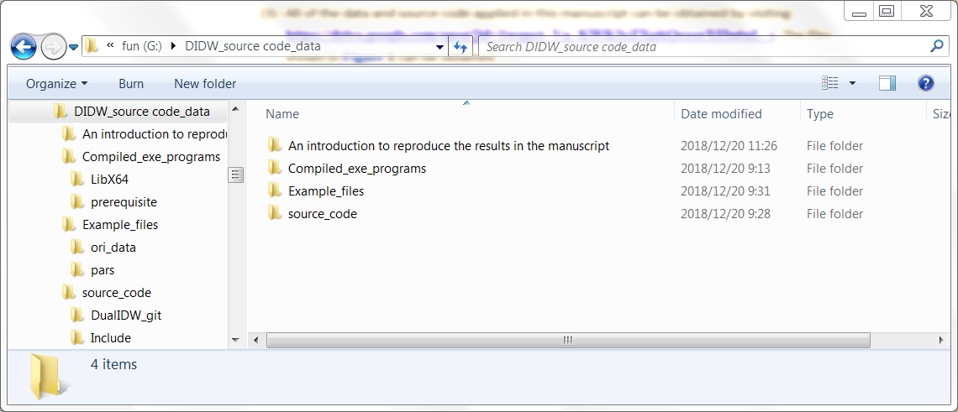

**Figure 1**

## Operation steps

There are four operation steps to perform the DIDW-based estimation or simulation.

1. Open the file “DIDW\Compiled_exe_programs\LibX64\Sgems_X64.exe” (**Figure 2**). Normally, the plug-in of DIDW will be loaded automatically and shown in estimation category of the algorithm panel (**Figure 3** and **Figure 4**).

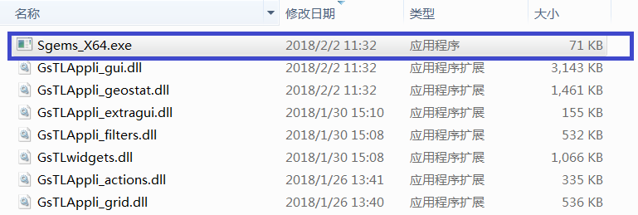

**Figure 2**

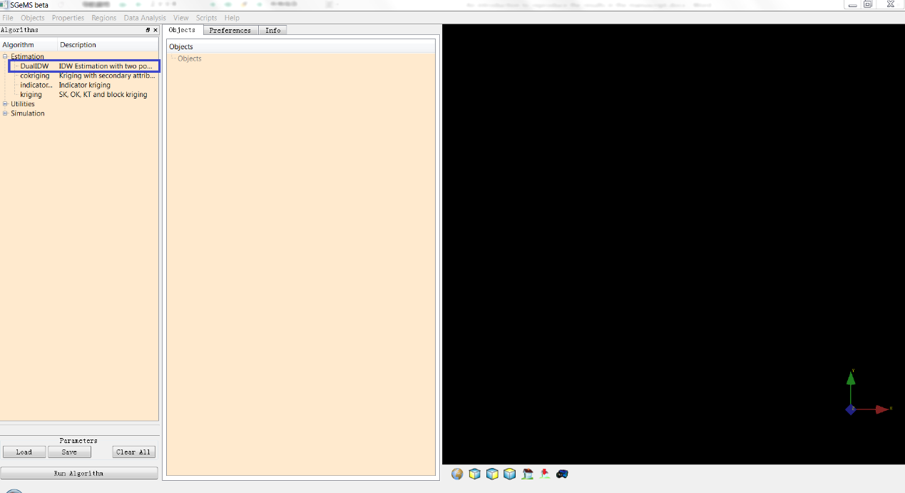

**Figure 3**

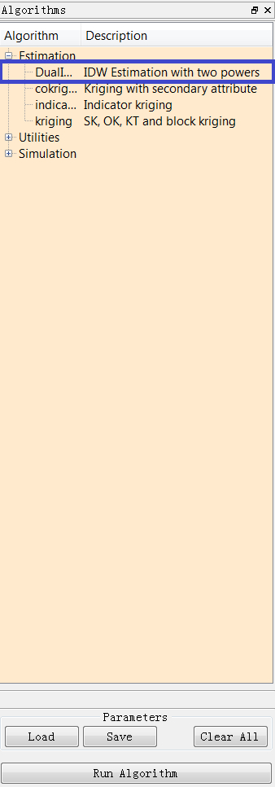

**Figure 4**

1. Use the menu “File | Open project” to open the test project files “DIDW\ Example_files\ori_data\WalkerLake_DIDW.prj” (**Figure 5** and **Figure 6**).

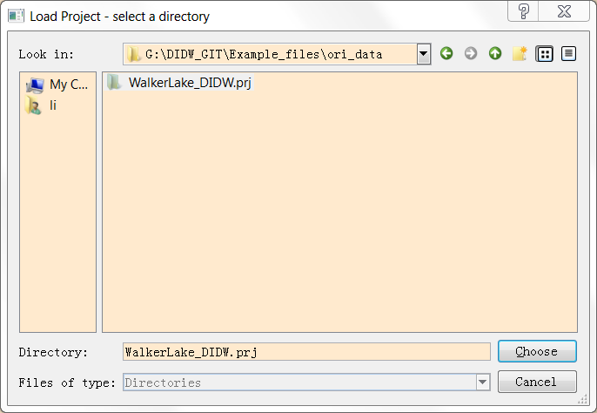

**Figure 5**

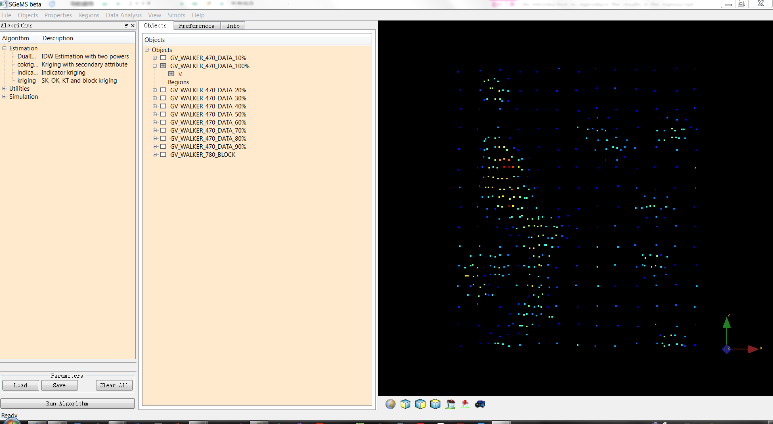

**Figure 6**

1. Click the “load” button (**Figure 6**) to open one of the general interpolation parameters. The DIDW-estimation algorithm will be located automatically, and the common parameters in an estimation process, such as the variogram model, search neighborhood, estimation grid and property, hard data and property will also be set automatically. See **Figure 7**, **Figure 8**, **Figure 9** and **Figure 10**.

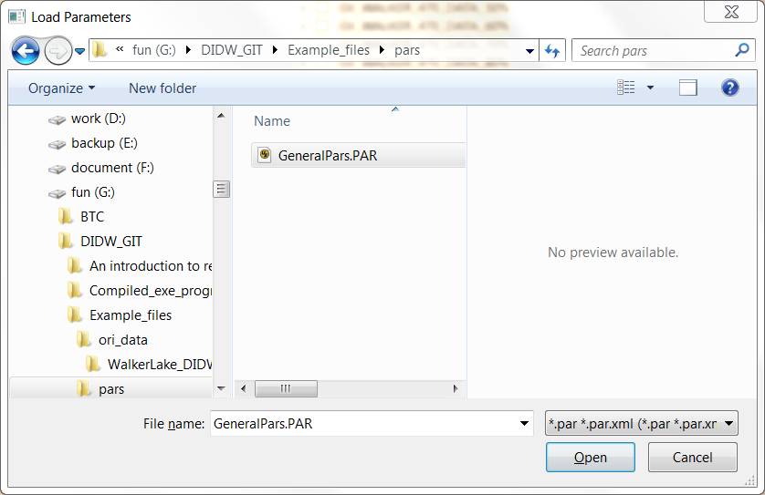

**Figure 7**

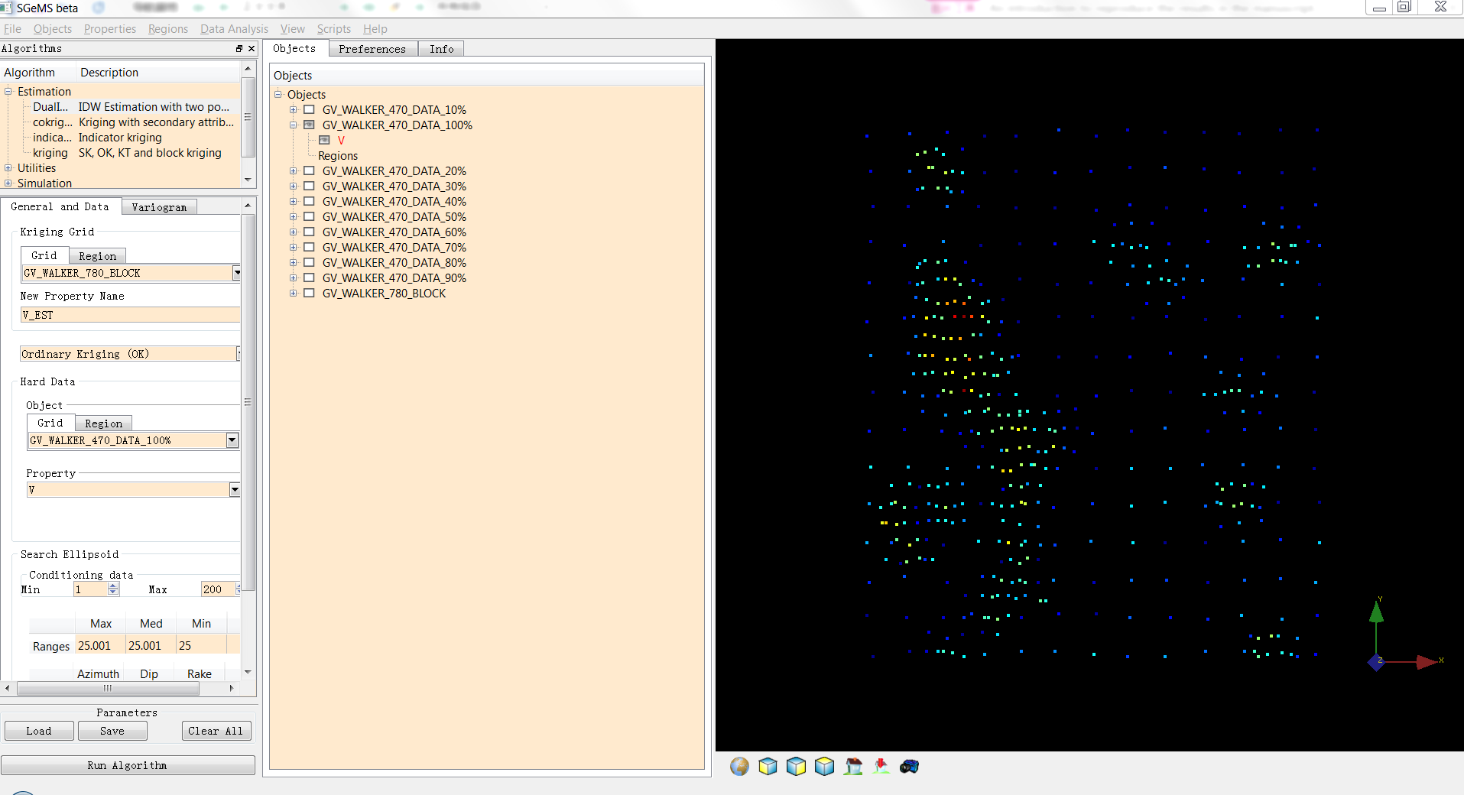

**Figure 8**

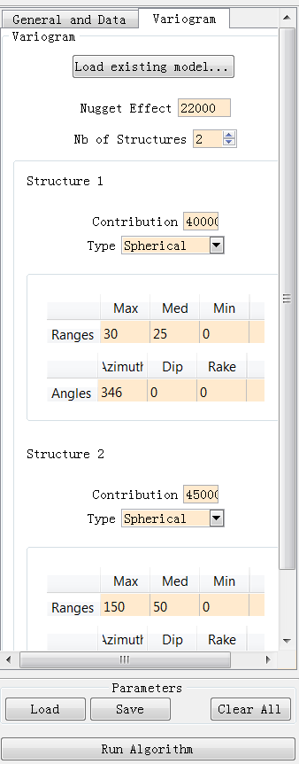

**Figure 9**

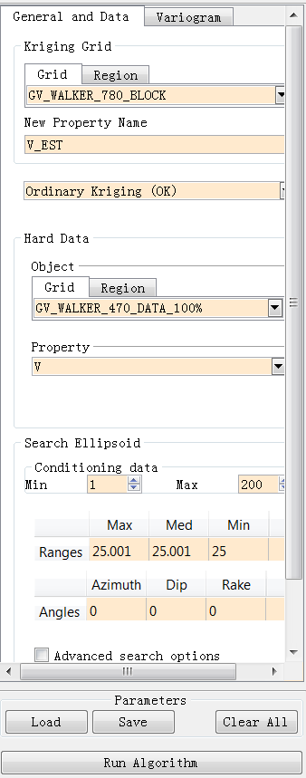

**Figure 10**

1. Click the “Run algorithm” button in **Figure 10** to perform the algorithm. The value of “The new property” is suggested to be changed to identify the method being applied. Following the above steps, an estimation map such as that shown in **Figure 11** will be produced. Besides, the accompanying results, such as the estimation error variance (**Figure 12**), absolute error (**Figure 13**), also could be observed.
2. Please note that all of the data files in the project can be exported for further analysis using the menu (Object| Export Object).

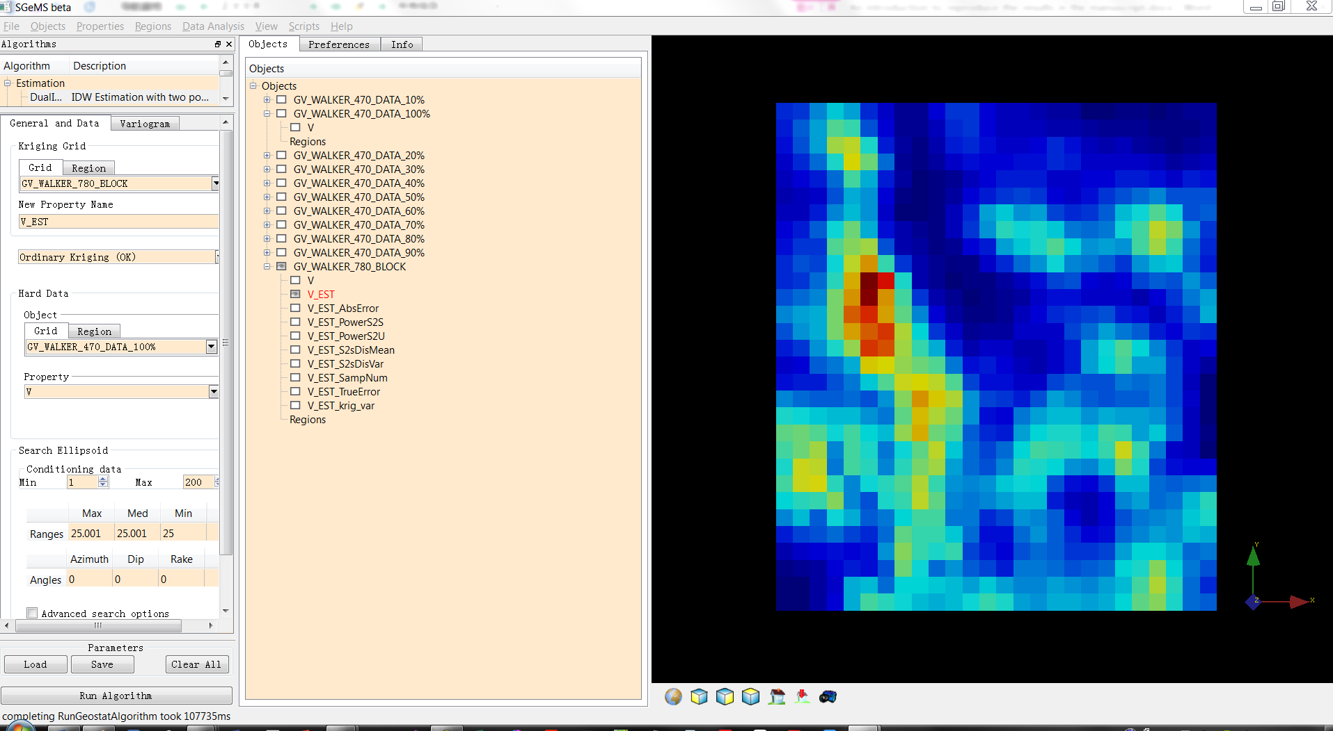

**Figure 11**

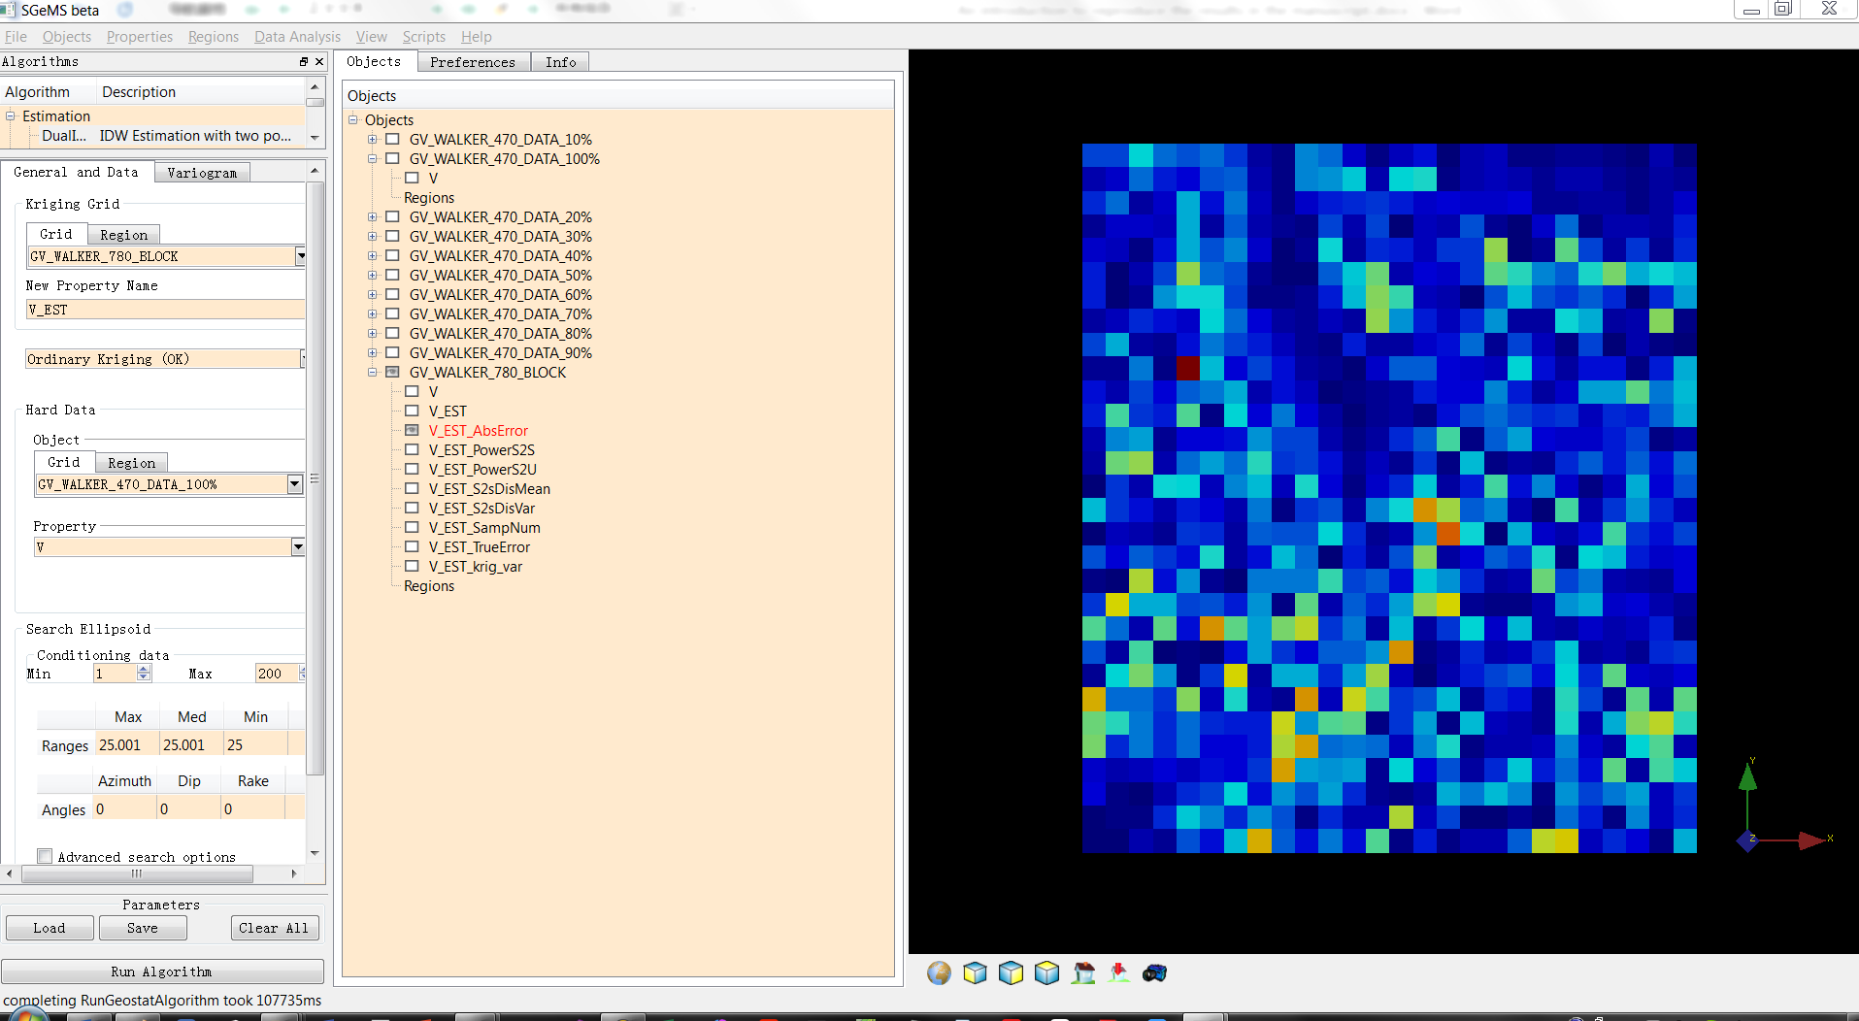

**Figure 12**

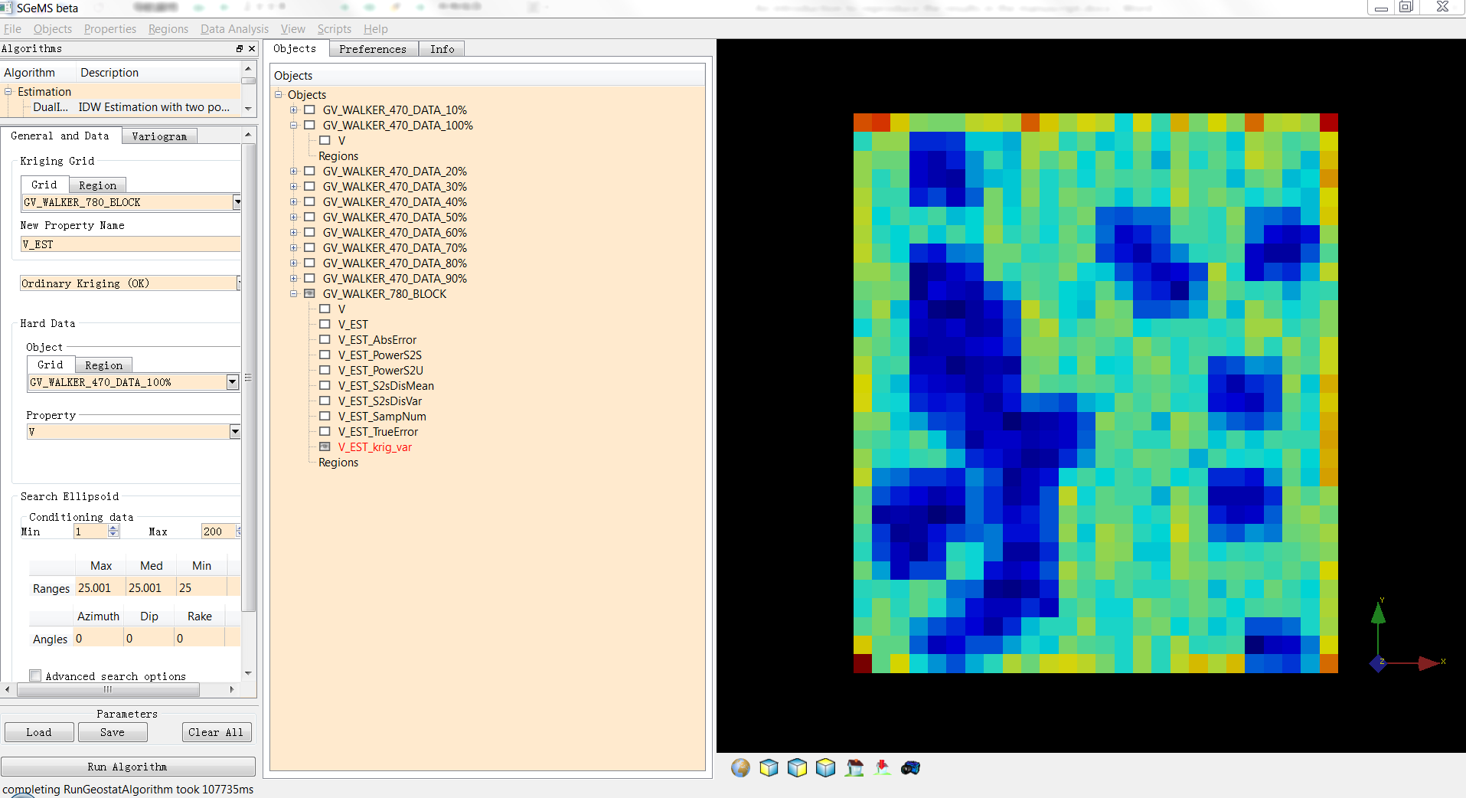

**Figure 13**

## Parameter configurations

**Figure 14** shows the detailed configuration of DIDW methods. Please note that the values of items ①-③ in this figure should be changed to produce the different modeling methods applied in the paper. Further explanations to set these items are illustrated below.

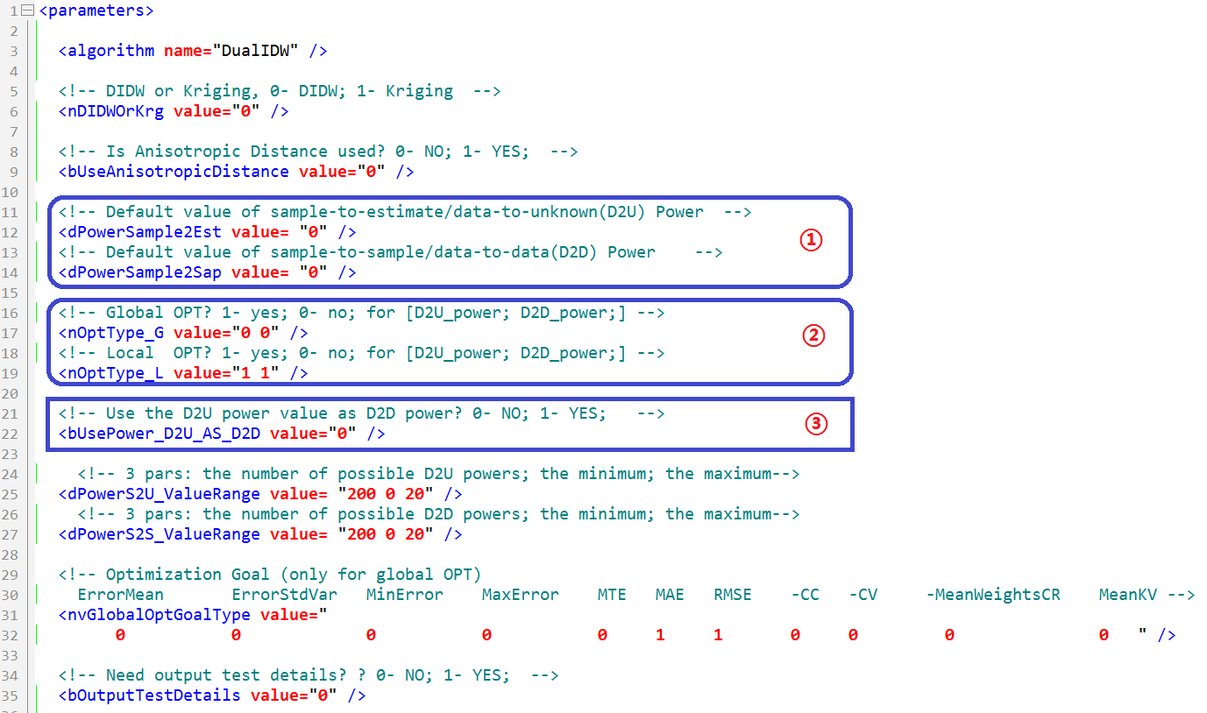

**Figure 14 Primary contents in the parameter file:**

“DIDW\Compiled_exe_programs\LibX64\CalProcess \ DIDW.par”

### Interpolating with globally constant exponents

In the case of using globally constant powers, parameters in Table 1 could be used to search the optimal exponents within the cross-validation framework.

If the appropriate powers are determined, parameters in Table 2 can be used to execute the DIDW interpolation for an unknown area.

Table 1

|  |  |  |  |
| --- | --- | --- | --- |
| **Estimation method** | **Value of item ①** | **Value of item ②** | **Value of item ③** |
| IDW-G | 0 | 1 0  0 0 | 0 |
| DIDW-GG | 0 | 1 1  0 0 | 0 |
| SDIDW-GG | 0 | 1 0  0 0 | 1 |

Table 2

|  |  |  |  |
| --- | --- | --- | --- |
| **Estimation method** | **Value of item ①** | **Value of item ②** | **Value of item ③** |
| IDW (IDW-G) with a global D-U power of | 0 | 0 0  0 0 | 0 |
| DIDW (DIDW-GG) with a D-U power , and D-D power |  | 0 0  0 0 | 0 |
| SDIDW (SDIDW-GG) with a D-U power of | 0 | 0 0  0 0 | 0 |

### Interpolating with locally varying exponents

Table 3 shows the parameter configuration of DIDW estimation with locally varying exponents.

Table 3

|  |  |  |  |
| --- | --- | --- | --- |
| **Estimation method** | **Value of item ①** | **Value of item ②** | **Value of item ③** |
| IDW-L | 0 | 0 0  1 0 | 0 |
| SDIDW-LL | 0 | 0 0  1 0 | 1 |
| DIDW-LL | 0 | 0 0  1 1 | 0 |

### Interpolating with locally varying D-U and global D-D power(s)

In the case of using locally varying D-U exponents and a globally constant D-D power, parameters in Table 4 can be used to search an optimal D-D power using cross-validation; and Table 5 can be applied to accomplish the estimation using the optimized exponent.

Table 4

|  |  |  |  |
| --- | --- | --- | --- |
| **Estimation method** | **Value of item ①** | **Value of item ②** | **Value of item ③** |
| DIDW-LG | 0 | 0 1  1 0 | 0 |

Table 5

|  |  |  |  |
| --- | --- | --- | --- |
| **Estimation method** | **Value of item ①** | **Value of item ②** | **Value of item ③** |
| DIDW-LG with a D-D power, |  | 0 0  1 0 | 0 |